Using Scale Drawing Worksheet

Question 1
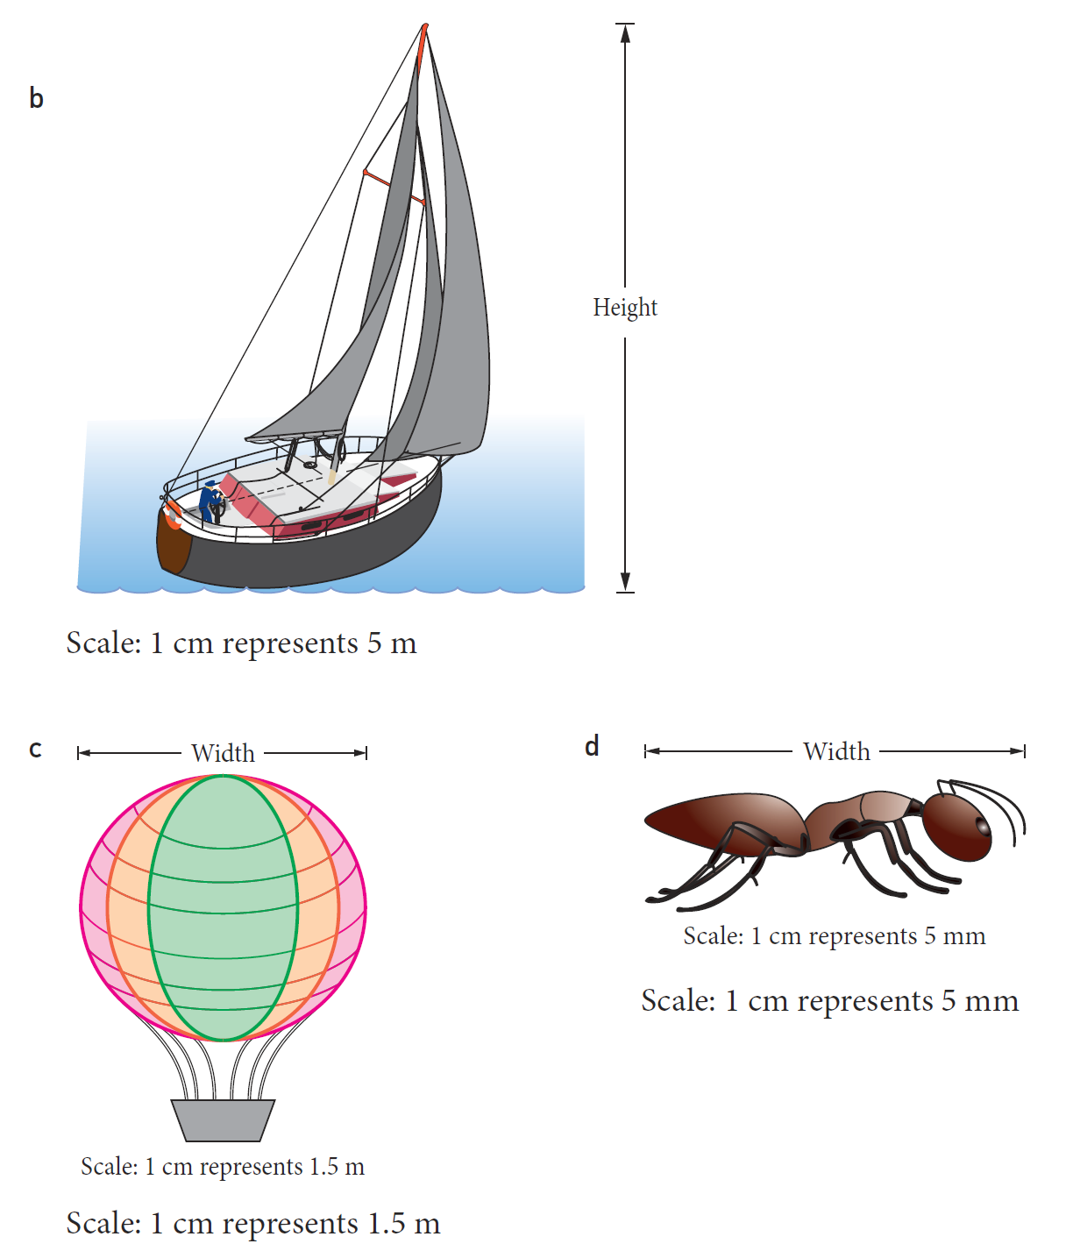

Question 2


Question 3
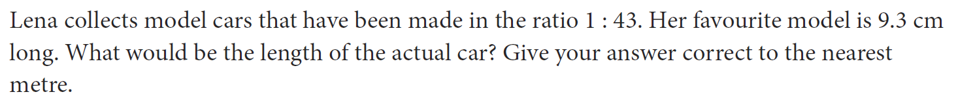

Question 4
